**Java Exceptions and Error Handling**

1. Write a Java program that reads user input for two integers and performs division. Handle the exception that is thrown when the second number is zero, and display an error message to the user.

Failure Response:

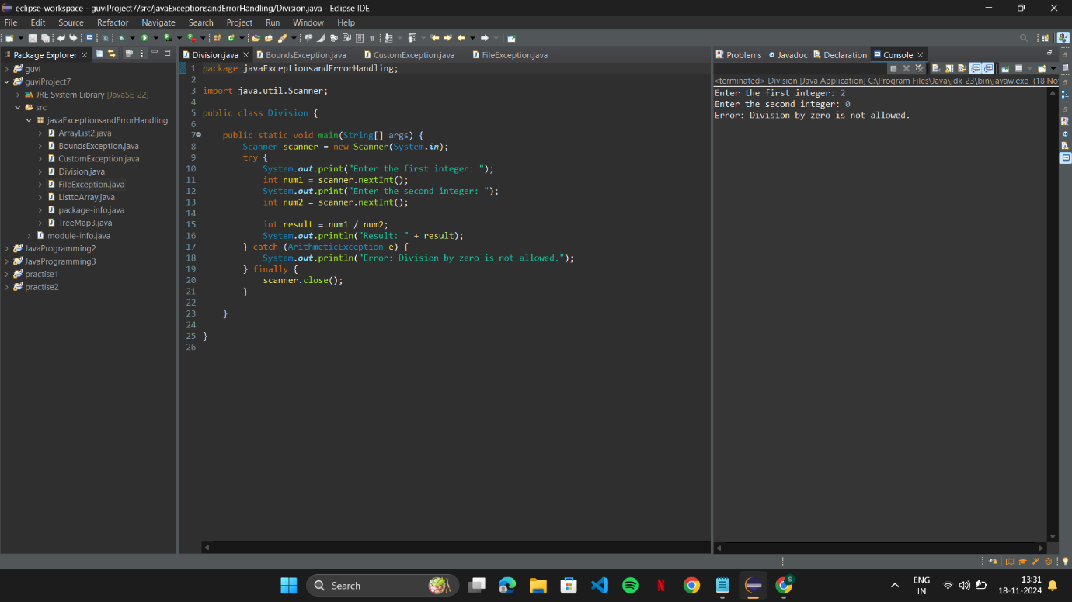

Success Response:

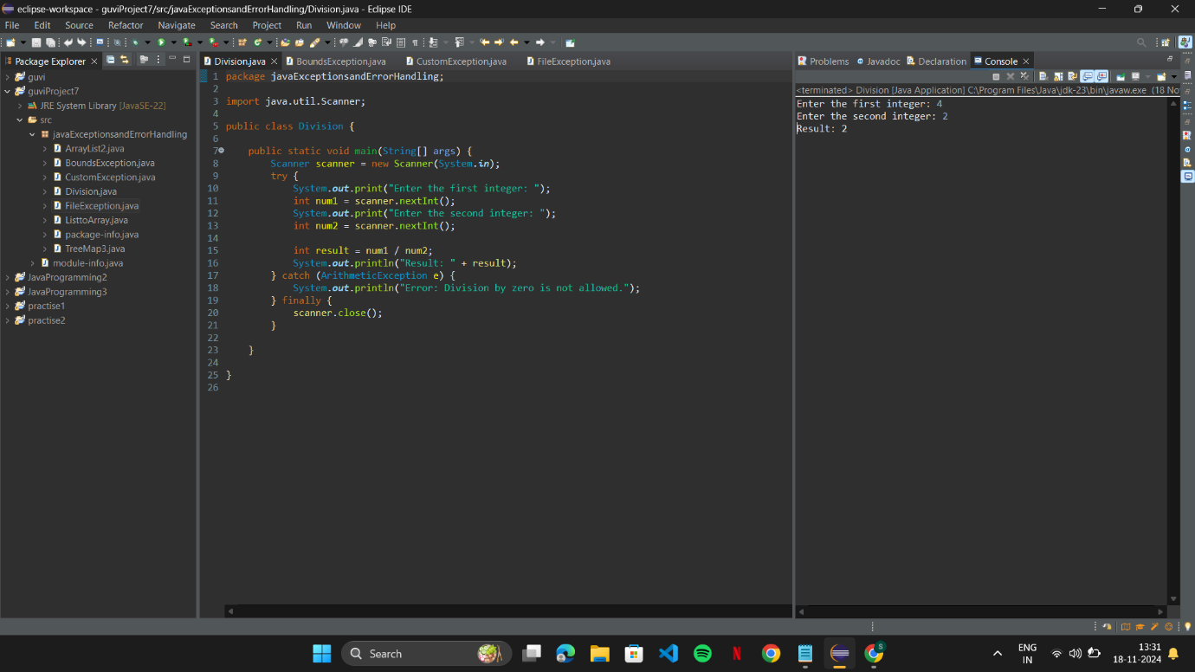

1. Write the code of ArrayIndexOutOfBoundsException & StringIndexOutOfBoundsException?

Failure Response:

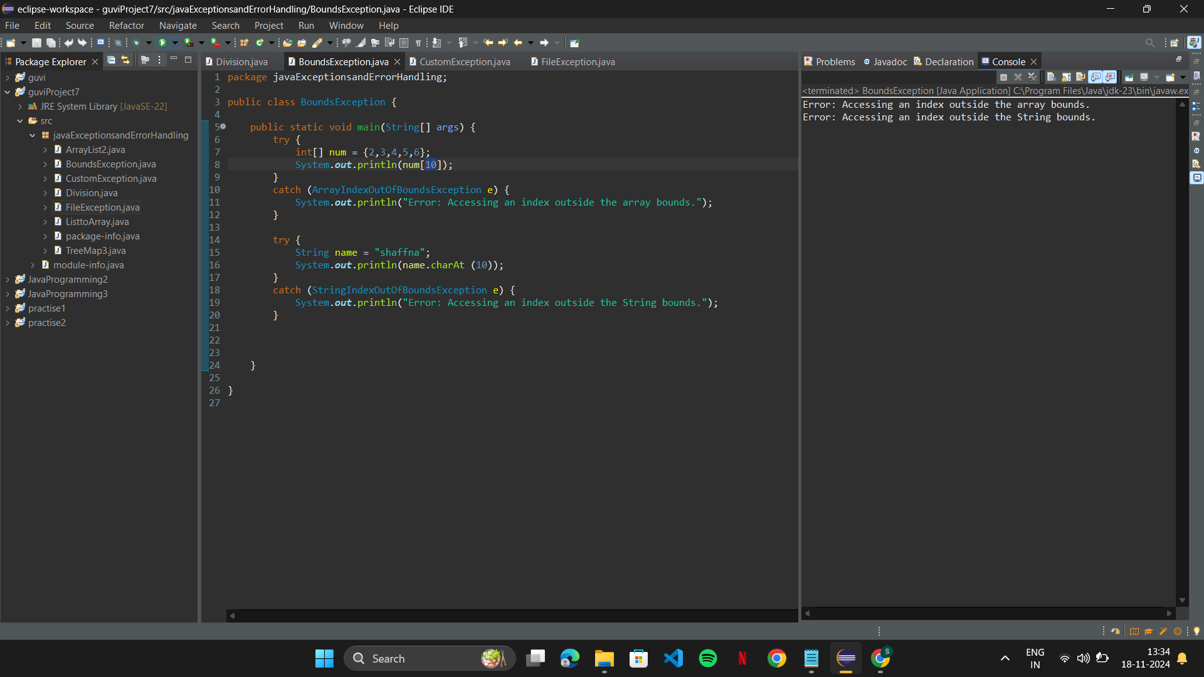

Success Response:

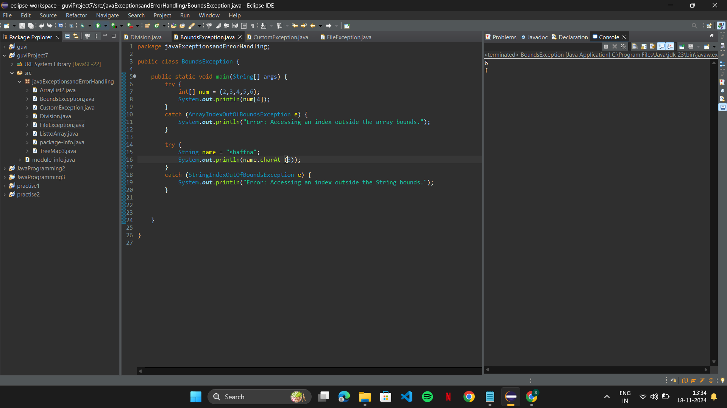

1. Create a custom exception in Java called "InvalidAgeException" that is thrown when the user enters an age less than 18. Implement exception handling in a Java program to catch the "InvalidAgeException" and display an error message.

Failure Response:

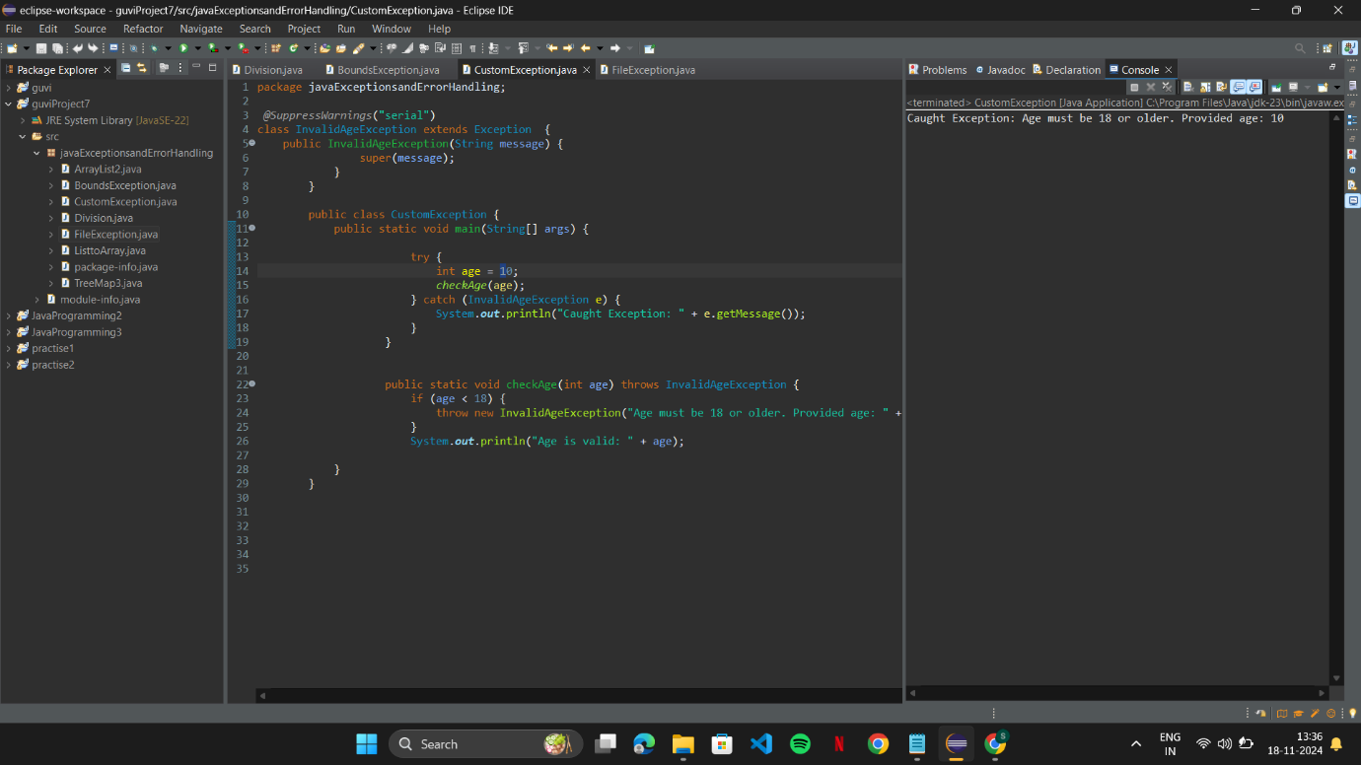

Success Response:

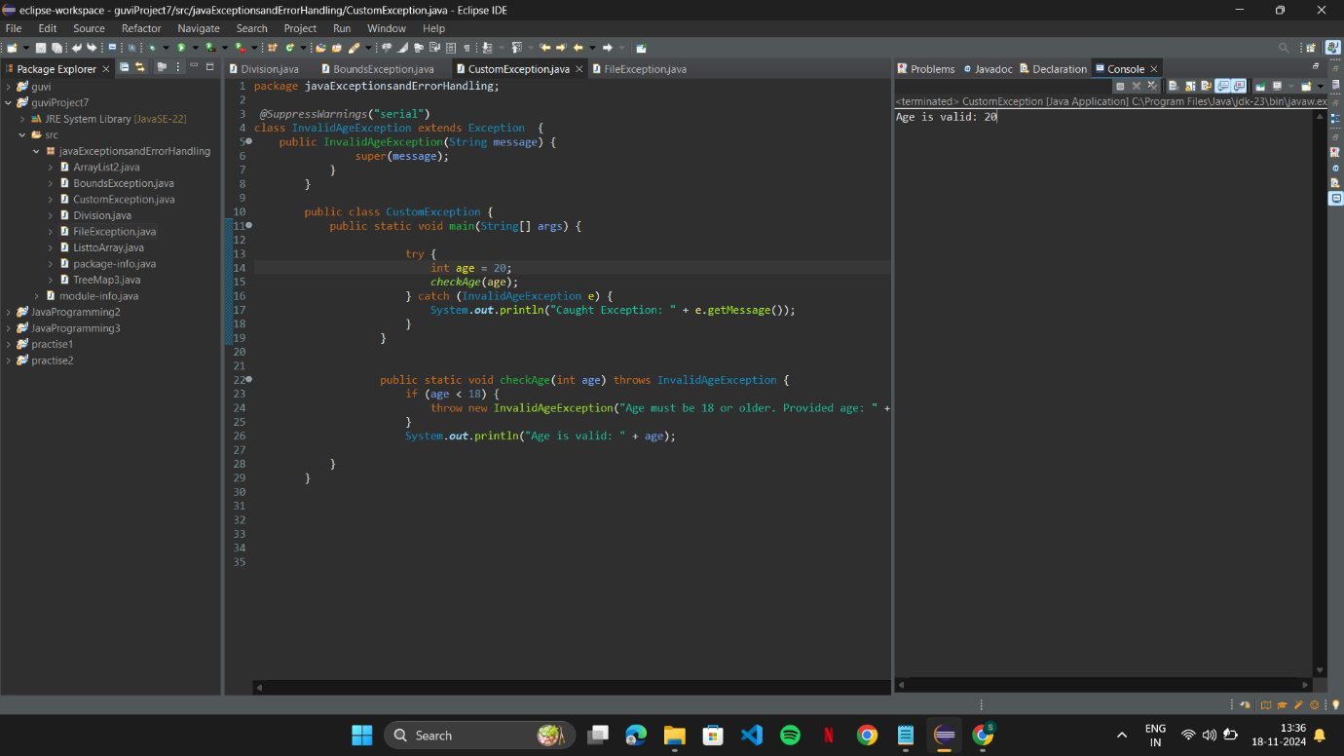

1. Implement exception handling in a Java program that reads data from a file. If the file does not exist, throw a "FileNotFoundException" and display an error message to the user.

Failure Response:

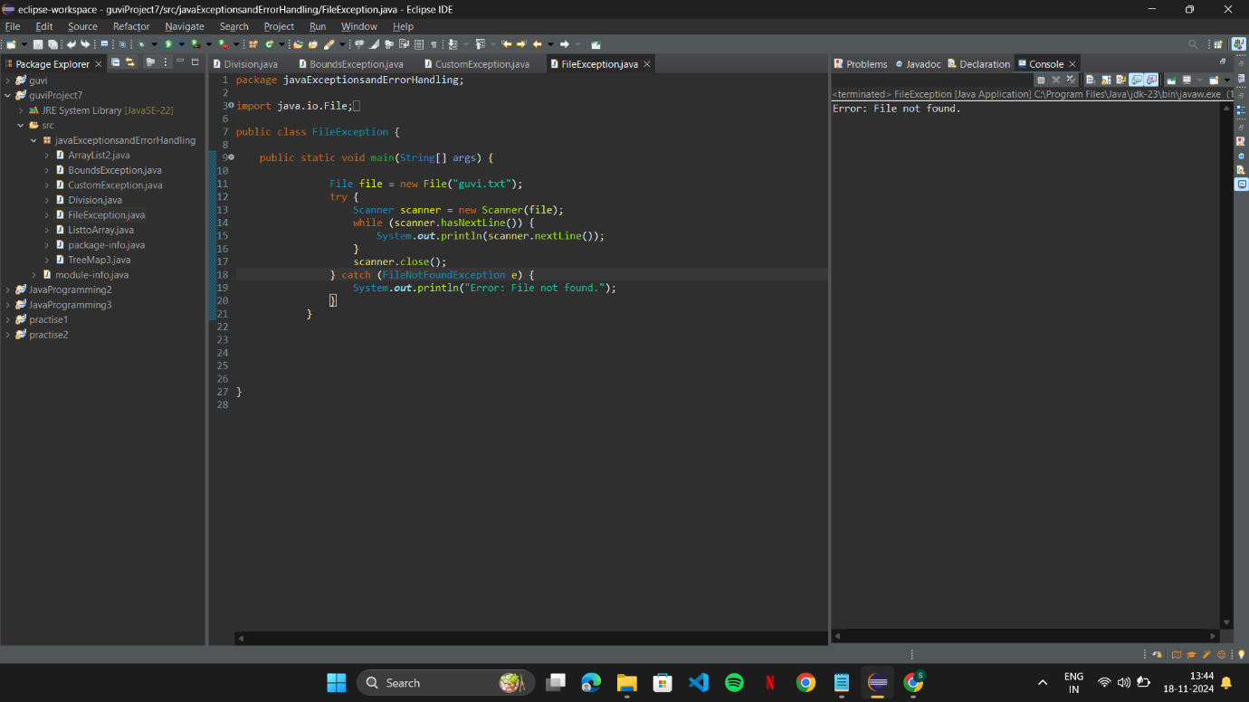

Success Response:

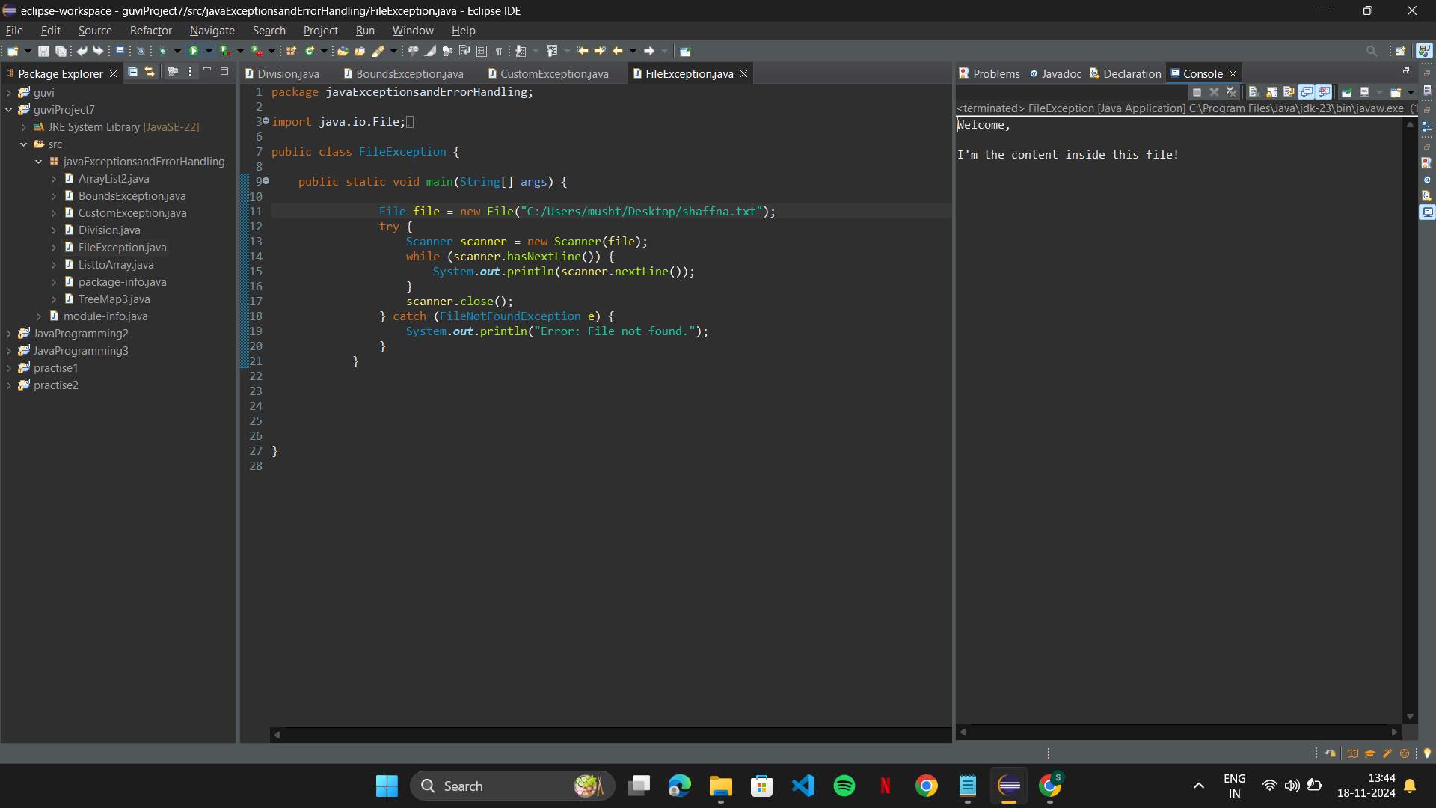

1. Write a Java program to create an ArrayList of strings and then remove all the elements from the ArrayList.

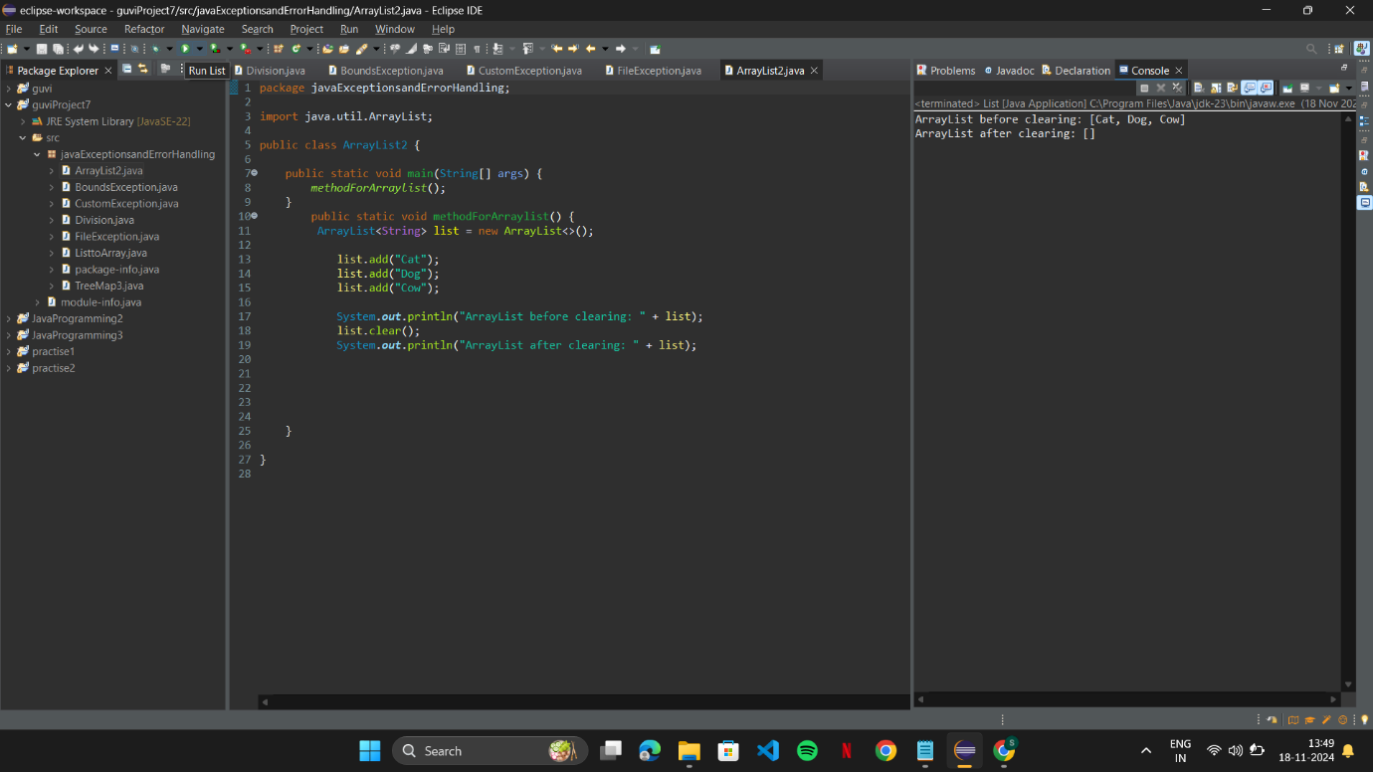

1. Write a Java program to create a TreeMap of employee IDs and names. Then, print out the names of all the employees in alphabetical order.

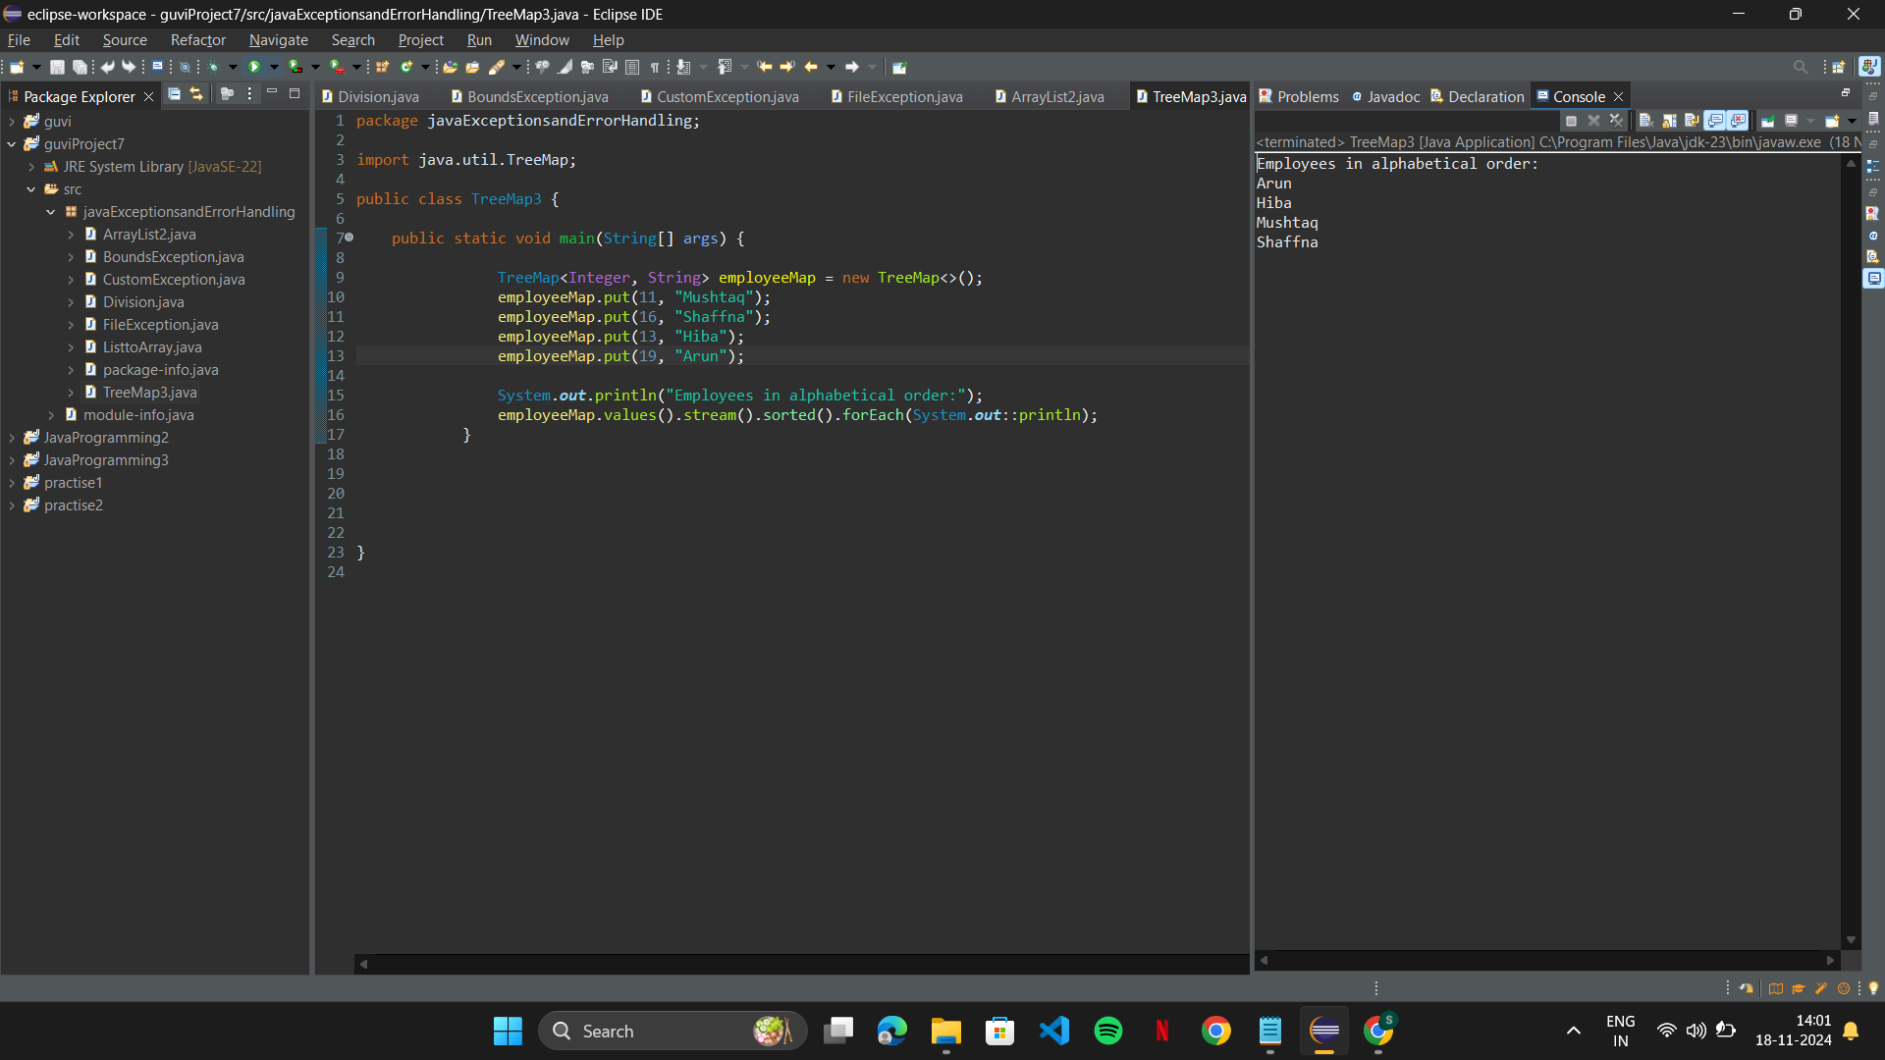

1. Write a program to convert List to Array.

